

*Assignment Cover Sheet:* Please attach this cover sheet to the front of **every assignment** you submit to the university. Please be sure to **sign the declarations below** before you submit this sheet. Failure to sign the declarations may result in your work being unmarked.

|  |  |
| --- | --- |
| **Student Name** | Edlira Taipi |
| **Student ID** | 24025443 |
| **Programme** | MSc Digital Marketing |
| **Module Name & Code** | EMERGING TECHNOLOGY AND SOCIAL TRENDS - DGM22701 |
| **Assignment Name & No.** |  |

**Declaration:**

I have complied with [Ravensbourne University’s Academic Regulations](https://www.ravensbourne.ac.uk/asset-bucket/prod/2023-08/Ravensbourne%20University%20General%20Academic%20Regulations%202023-24.pdf) and have **acknowledged** the work and ideas of others that I have used in the production of this assignment.

Signed: _________Edlira Taipi___________________

I have read the MSc Digital Marketing course statement on AI and can confirm that **I have not used** AI/LLM technologies in the production of this assignment:

Signed: ____________________________

I have read the MSc Digital Marketing course statement on AI and can confirm that **I have used** AI/LLM technologies in the production of this assignment:

Signed: _________Edlira Taipi___________________

|  |  |
| --- | --- |
| **Software used and publisher:**  i.e., ChatGPT4/Canva Magic Studio  Grammarly |  |
| **Links** |  |
| **Description and rationale of the use of AI software:** add evidence where appropriate. | I have used AI as a research tool not as a asset. |

Date:____________25/01/2025________________

Student Number: F2411085

Student ID: 24025443

Student Name: Edlira Taipi

Module Code: DGM22701

EMERGING TECHNOLOGY AND SOCIAL TRENDS

**Table of Contents**

Blog post 4

Title - *Artificial Intelligence and the NHS - caring for the UK populace* 4

Introduction 4

Summary of technology 4

Personal Reflection 5

Conclusion 6

Bibliography 6

Report 7

Introduction 8

Current situation analysis 9

Chosen tactics and their relevance 11

Application and Recommendations 13

Conclusion 16

References 17

# Blog post

## Title - *Artificial Intelligence and the NHS - caring for the UK populace*

## Introduction

Artificial intelligence is one of the key technological advancements in contemporary human society that has revolutionised various aspects of health and well-being facilities as well. The National Health Services has set out on a journey of large-scale digital transformation using artificial intelligence to bring about widespread advancements in the health and well-being scenario of the country. In this blog, let us explore some ways that AI is helping the NHS in its care and service goals.



**Figure 1: The NHS’s AI lab**

(Source: NHS England, 2024a)

## Summary of technology

Artificial intelligence is a revolutionary technological advancement that essentially mimics human actions and reasoning. In the healthcare and well-being sector, Ai is known to have multiple benefits which include rapid diagnosis, efficient management of patient health records, patient education and monitoring, drug development and many more. The NHS too is excited about the adoption of AI in the country’s health and wellbeing infrastructure. As a part of the NHS’s strategic vision for 2030, multiple NHS trust hospitals have opted for various AI tools and technologies operating in various health and well-being aspects.

## AI impact on Healthcare, its opportunities and challenges

AI has created a revolutionary changes in healthcare by making more preventive, predictive and personalised service. The opportunity of AI created by improving the healthcare system by giving personalised service to the patients. Patients can gain more insight about healthcare facilities through the implication of AI. However, cyber threat is one of the challenges which can create problem in healthcare system. Data privacy is another challenge which can be considered for healthcare in UK.

AI allows care providers to collect and assess substantial volumes of patient data and generate personalised and person-centred care approaches, while assisting caregivers in various administrative and technical activities. Nearly 54% of consumers and 76% of the NHS staff have been excited about the use of AI in patient care, especially for various administrative activities, rather than being involved directly in patient care. From a marketing perspective, AI has been able to personalise patient experience and analyse community health and well-being needs to design suitable care plans while also providing individuals with 24/7 access to online health services with the help of automated chatbots and customised responses.

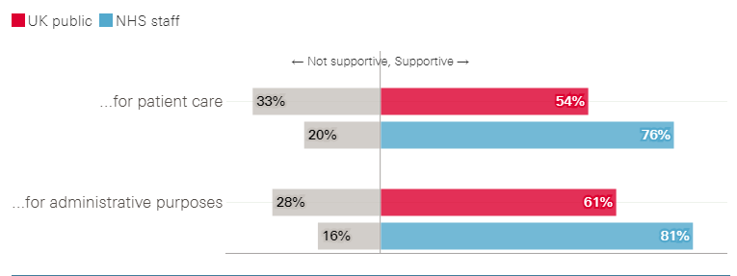

**Figure 2: NHS staff and public opinion about AI use in healthcare**

(Source: The Health Foundation, 2024)

## Personal Reflection

My personal interest in Artificial intelligence originated with my encounter with an NHS chatbot while I was looking for some health tips while recovering from a serious case of flu. I was looking for some basic medications to ease my symptoms as well as some dietary suggestions to help me regain my energy. The chatbot was really helpful and provided me with some excellent suggestions about the basic medications and dietary options. It also showed me an advertisement for a local community health centre where I could get myself tested and cared for in less than an hour’s drive. This experience showed me how AI has necessarily transformed the health and well-being scenario in the country and how this technology has transformed the marketing scenario in the health and social care sector and efficiently connected patients to suitable care providing facilities.

## Conclusion

AI is technology that has essentially revolutionised the health and social care services of the UK, including patient care, administrative activities as well as marketing experiences. With the help of this technology, organisations like the NHS can help patients locate the nearest health care facilities and provide them with the necessary care and support. It holds immense potential to essentially transform the healthcare experience for the entire UK populace.

## Bibliography

Chaffey, D. and Ellis-Chadwick, F. (2019). *Digital marketing: Strategy, implementation and practice*. Harlow: Pearson.

Juska, J. (2021). *Integrated marketing communication: Advertising and promotion in a digital world*. New York: Routledge.

Marr, B., 2024. *4 Powerful Examples Of How AI Is Used In The NHS*. Available at: https://bernardmarr.com/4-powerful-examples-of-how-ai-is-used-in-the-nhs/. (Accessed 22 November 2024)

The Health Foundation, 2024. *AI in health care: what do the public and NHS staff think?*. Available at: https://www.health.org.uk/publications/long-reads/ai-in-health-care-what-do-the-public-and-nhs-staff-think#:~:text=Over%20half%20of%20the%20UK,%25%20of%20NHS%20staff%20surveyed). (Accessed 22 November 2024)

# 

# Report

**Executive summary**

The NHS could implement contextual and data-driven marketing services with the help of various technological developments like AI, generative AI, IoT and Chatbots to collect patient data and customise their care experience. It has been found that AI technology integration in the marketing has developed the scope for identifying the customers preferences for the personalised services. This developed the customer's experience in the brand. Chatbot and the data drone AI technology has been assisting the company to deliver high quality communication. Hence, the customer's experience with the brand has been developing. These tools will help the organisation cater to emergent care needs of its patients and ascertain their due affluence and well-being.

## 

## Introduction

***Importance of emerging technology in modern marketing***

The emerging technology of AI has been helping companies in different sectors to serve customers as per their choice by identifying their purchase preferences. It has been found that the healthcare industry included AI technology in the marketing of their service in order to assure the customers about their priorities over their good health maintenance. The study will focus on impact of AI in NHS healthcare system.

**Focus and rationale for selecting the NHS as a brand and tactics**

The NHS has been using AI technology in the development of the marketing of its services. The marketing of AI-generated health and wellbeing strategies helped in developing the growth of digital health by 9.14% in 2024 (Statista, 2024). Thus, emerging AI in health and well-being promotion has been significant for the healthcare industry of the UK.

**Outline what the report will cover**.

This report will cover the current technological marketing strategies that have been followed by the NHS to improve their marketing of healthcare facilities. The technologies which are used in marketing for the promotion of health and well-being will be evaluated by adhering to the importance of existing tactics.

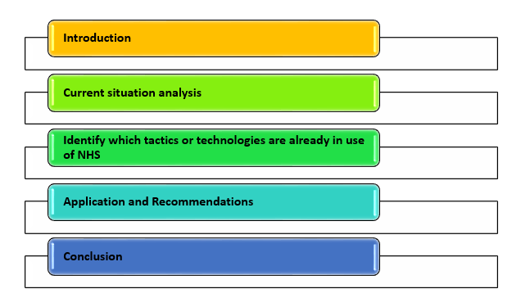

**Figure 3: Outline of the report**

(Source: Self-developed)

## Current situation analysis

***Discuss the current marketing strategies employed by NHS***

***SEO:*** “Search Engine Optimisation” has been used by the NHS for their development of brand awareness. This has been found NHS Wales has been using Crawling & Indexing for their SEO marketing which helps in resolving the queries of the customers. This technology also helps in setting the ranking of the company in the online platform. Thus, this NHS has developed the visibility of the brand in larger markets.

***Contribution of LOGO:*** another strategy that the NHS has been using in their promotion of the barns is the logo. The style which is used by the NHS in their logo is known as lozenge. This is a representation of the NHS’ values and purpose for providing high-quality care service to their customers. The logo evokes the trust, condense and sense of security of their care service receivers.

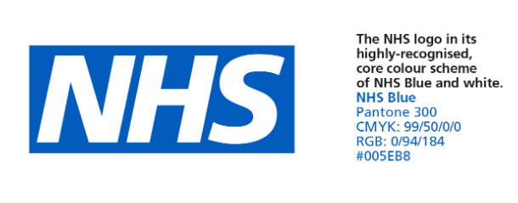

**Figure 4: Logo of NHS**

(Source: NHS, 2024b)

**Email marketing:** Another marketing tactic that has been used by the NHS is Email marketing (CMS Support, 2024). It has been found that companies promote the event for their health and social care via email marketing strategies (NHS, 2024b). In order to keep continuing their connection with the customers, the company posts their daily updates of the service through their email.

***Apps:*** one of the major features of the mobile app of the NHS is the “One You drinks tracker” (CIM, 2024). This technology has been helping to make the people of the UK aware of the brand's commitment to providing a healthy lifestyle to the people by ensuring the prevention of the consumption of alcohol.

***Identify which tactics or technologies are already in use of NHS.***

***Contextual tactics***

***Use of chatbot***

According to a survey by Statista, 59% of healthcare professionals declared that AI-powered healthcare systems have been effective in promoting good health among the people of the UK (Stewart, 2024). Similarly, the NHS has been using the chatbot for the development of the doctor's patient communication. On the other hand, the person who visits the company website is the chatbot for an automated messaging system. This can provide an effective platform to the patent of the company for communicating with the doctors of the NHS (Digital Regulations, 2024). the customer service system used in the chatbot that resolves queries of the patent and helps in setting the appointments. Thus the company developed a high level of trust and reassurance over the services that the NHS provide to their patients (NHS England, 2024b).

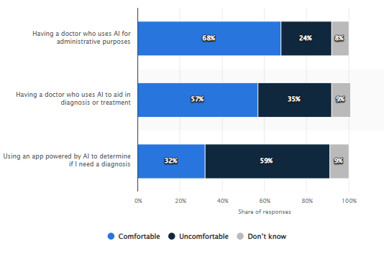

**Figure 5: Preferences of AI in health care system**

(Source: Stewart, 2024)

***The data driven tactics***

Almost 72% of UK-based companies use data-driven technologies that are connected to artificial intelligence (GOV, 2024). This helps in the improvement of the data management which promotes the development of the marketing process. In the NHS this technology is used for the promotion of the individual care system. This helped the NHS to promote them as the customer preference-driven brand in the UK healthcare industry (HEE NHS, 2024). The NHS AI lab has been working on the development of imaging for handling the data and information (NHS, 2024a). The imaging technology incorporated with AI has ensured that the company safely collects the data of the customers and validates them through the AI software. The NHS has been developing the worthwhile use of patient data in the development of personalised and effective treatment processes for their patients.

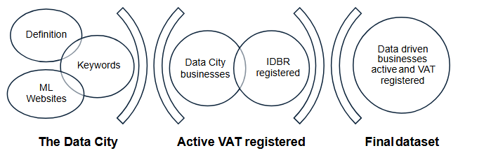

**Figure 6: Development of the data SET for the data driven decision**

(Source: GOV, 2024)

## Chosen tactics and their relevance

***Contextual tactics of marketing***

***Define:***

Contextual tactics of marketing define the process of serving the proper information to the customers at the right time (Nezhadkian *et al.* 2023). For the promised advertisement process often this tactic is used by the brand for attracting the customers.

***How NHS use the tactics***

For contextual tactics the AI technologies integrated chatbot has been used by the NHS. Automated chatbot service of the chatbot has been helping the organisation to manage customer communication (Digital Regulations, 2024). The chatbot has helped the company manage customer communication even though their workers for the customer care service were not available. The customers are free to make queries and complaints through the technology which helps in the development of care services for the NHS.

***Relevance***

The chatbot is used in the marketing process for the development of customer experience. The NHS has reviews on the customers who have used their new automated healthcare system. This can be found that chatbots have helped in promoting mental health services to customers (Yahoo, 2024). The customers reviewed that this system has been assisting in the management of the mental condition. Upon asking for therapies, the chatbot provided all the details about the therapist and their treatment process throughout the session. The AI-generated information is also highly effective similar to human responses.

***Data driven tactics***

***Define :***

The data-driven tactics refer to the process of decision-making for the business by following the market trends and customer feedback (IBM, 2024). This helps in the development of betterment of the services that track the more customers for the health care services.

***Tactic Used by NHS :***

The AI-generated data-driven technology is used by the NHS for the development of their service quality. The company collects the data related to health records which helps in delivering the personalised care service to each patient (HEE NHS, 2024). The company ensures that the data of the customers are used only for control over the healthcare system during the epidemic and to ensure the safety of the customers.

***Relevance***

The data-driven tactics of the NHS helped in identifying the customer’s individual preferences. For quick responses to the cash of their customers, the company used their application that helps in messaging and chatting with their parents wherever they need help. In mobile applications of the NHS, this has been found that the NHS has been assisting the customers. This has been promoting the brand as one of the most trustworthy (NHS England, 2024b). The company has been assisting their customers by using the application. As per the below figure, the mobile application drove the customer's enquiries to the patent dataset from the system sent the data to the communication providers and sent emails to the customers (NHS, 2024d). Hence, the use of the mobile application has been helping the company to promote customer service to the citizens of the UK.

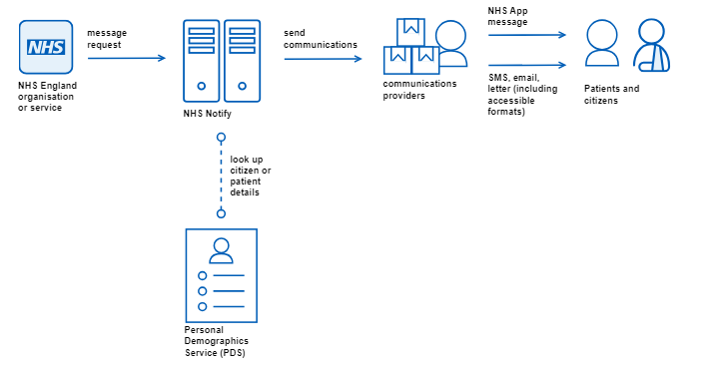

**Figure 7: Personalised service development by NHS**

(Source: NHS, 2024d)

## Application and Recommendations

***Being contextual***

Being contextual would imply that healthcare organisations could design marketing campaigns that directly relate to patient needs and requirements. With the help of this tactic, the NHS could design marketing campaigns or initiatives that cater to specific health and well-being needs of patients. For instance, the NHS has long operated a Stop Smoking campaign which helps patients quit smoking and find suitable ways to overcome such cravings (Better Health, 2024). This campaign is a key marketing effort implemented by the NHS which helps the organisation promote its position as a country-wide promoter of health and well-being. According to Crane (2022), campaigner feeling has been analysed where 175 self-identified NHS campaigner composed over 38,000 words for new and rich qualitative data. This showcased the liking of NHS campaign which help to promote the brands.

Here, it must be noted that such campaigns are specifically directed to a particular target group and are thus contextual to patient needs and worries. Thus, it can be seen that Being contextual enables the NHS to design marketing campaigns and initiatives that shed light on key care and well-being concerns of patients.

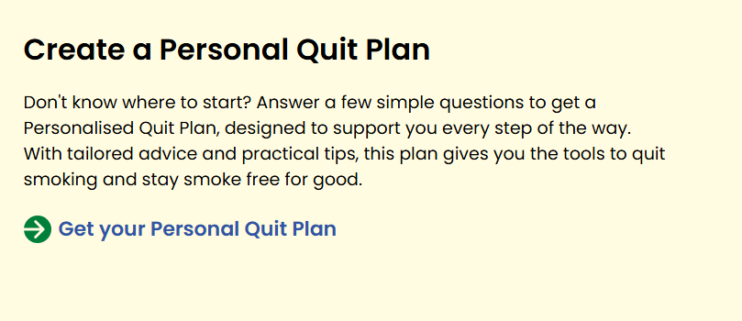

**Figure 8: Personalised quit smoking plan being provided by the NHS**

(Source: Better Health, 2024)

In this pursuit, various technological advancements can prove beneficial.

* **Using AI to collect and evaluate patient data** - Technological tools like Artificial Intelligence can be used to provide the NHS with emergent health requirements in various parts of the country (GOV, 2023). Until now, most healthcare facilities in the UK use AI for identifying long-stay patients and improving overall patient outcomes. However, the organisation can use these technologies and tools for designing effective and interactive marketing campaigns that best suit the emergent health needs of the patients in the country.
* **ChatGPT for designing specialised marketing campaigns based on patient symptoms and requirements** - the NHS could use technological tools like ChatGPT to obtain necessary suggestions or creative ideas for designing truly effective and interactive marketing initiatives. With the help of this generative AI tool, users can increase efficiency of various creative campaigns and initiatives by providing them with necessary pointers or prompts, based on the criteria input by the user (Dimitrieska, 2024). The NHS could also use ChatGPT to design creative and duly contextual marketing campaigns based on patient needs and searches.

***Being data-driven***

A data-driven approach in marketing is characterised by the use of a variety of consumer data such as frequent searches, consumption patterns and many more (McKinsey & Company, 2021). This marketing approach is revered for being precise and duly efficient as it allows the service provider to identify emergent service demands in society and address the same. With the help of this marketing approach, the NHS could also ensure due efficiency and precision of its marketing campaigns. The organisation could use such precise marketing efforts to help promote its purpose of caring for the entire UK populace. This would not only benefit the overall health of the country residents but also promote the NHS’ brand reputation and recognition.

In order to implement a truly data-driven and efficient marketing initiative., the NHS could utilise various technological tools which may include the following:

* **Chatbots and precisions service delivery** - the NHS could design and deploy a unified chatbot service instead of simply relying on the chatbots being used by its trust institutions. With the help of these chatbots, the NHS could directly communicate with the patients, answer key health questions and also guide them to nearby facilities for addressing their care needs. Chatbots are often viewed as helpful tools that can enhance the overall efficiency and patient satisfaction associated with a care approach (Palanica *et al.,* 2019). In this case, the NHS would diversify the existing use of chatbots in healthcare to collect necessary patient data and use the same for designing duly efficient and creative marketing initiatives.

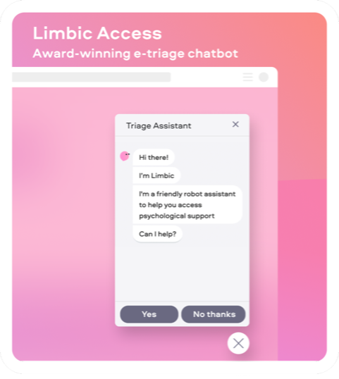

**Figure 9: NHS’s chatbots providing mental health assistance**

(Source: NHS England, 2024b)

* **IoT and patient data generation and evaluation** - Internet of Things devices also find extensive use in the existing health and well-being landscape of the UK. These devices can act as invaluable sources of patient data, which when transcribed with the help of sensor technologies, can be used to generate patient-specific marketing leads. Thus, the NHS can use IoT devices to provide patients with specially personalised health prompts based on the patient health data being shared through these devices. This would not only benefit patient health but also enhance NHS brand reputation.

## Conclusion

As depicted above, the NHS’ marketing efforts could significantly benefit with the incorporation of key digital marketing tactics. Being data-driven and contextual are key aspects of digital marketing advancements which can help organisations transform the overall consumption experience for their patients. The same holds for the NHS and its health and well-being services. The organisation could use various technological advancements like the Chatbots, Ai, generative AI and IoT devices to provide efficient care services to patients throughout the country.

# 

# References

Better Health, 2024. *Quit smoking*. Available at: https://www.nhs.uk/better-health/quit-smoking/#maincontent (Accessed 20 November 2024)

CIM, 2024. *NHS marks 70 years: The change in marketing over the decades.* Available at: https://www.cim.co.uk/newsroom/nhs-marks-70-years-the-change-in-marketing-over-the-decades. (Accessed 22 November 2024)

CMS Support, 2024. *Search Engine Optimisation.* Available at: https://cmssupport.nhs.wales/best-practice/search-engine-optimisation/ (Accessed 21 November 2024)

Digital Regulations, 2024. *Using an AI Chatbot to ease staff shortages and improve patient care.* Available at: https://www.digitalregulations.innovation.nhs.uk/case-studies/using-a-chatbot-to-ease-staff-shortages-and-improve-patient-care/ (Accessed 22 November 2024)

Dimitrieska, S., 2024. Generative Artificial Intelligence and Advertising. *Trends in Economics, Finance and Management Journal (TEFMJ)* Vol, 6, pp.23-33.

GOV, 2023. *Using AI to help identify long stay patients and improve outcomes*. Available at: https://www.gov.uk/government/case-studies/using-ai-to-help-identify-long-stay-patients-and-improve-outcomes (Accessed 20 November 2024)

GOV, 2024. *The UK Data Driven Market.* Available at: https://www.gov.uk/government/publications/the-uk-data-driven-market/the-uk-data-driven-market. (Accessed 19 November 2024)

HEE NHS, 2024. *Data Driven Healthcare in 2030: Transformation.* Available at: https://www.hee.nhs.uk/our-work/building-our-future-digital-workforce/data-driven-healthcare-2030 (Accessed 22 November 2024)

IBM, 2024. *What Is Data-Driven Decision-Making?.* Available at: https://www.ibm.com/think/topics/data-driven-decision-making (Accessed 20 November 2024)

McKinsey & Company, 2021. *The big reset: Data-driven marketing in the next normal*. Available at: https://www.mckinsey.com/capabilities/growth-marketing-and-sales/our-insights/the-big-reset-data-driven-marketing-in-the-next-normal (Accessed 20 November 2024)

Nezhadkian, M., Azimi, S.M., Ferro, A. and Nafei, A.H., 2023. A model for new product development in business companies based on grounded theory approach and fuzzy method. *Journal of computational and cognitive engineering*, 2(2), pp.124-132.

NHS England, 2024a. *NHS identity guidelines.*  Available at: https://www.england.nhs.uk/nhsidentity/(Accessed 20 November 2024)

NHS England, 2024b. *Using an AI chatbot to streamline mental health referrals*. Available at: https://transform.england.nhs.uk/key-tools-and-info/digital-playbooks/workforce-digital-playbook/using-an-ai-chatbot-to-streamline-mental-health-referrals/ (Accessed 20 November 2024)

NHS, 2024a. *Artificial intelligence (AI) and machine learning.* Available at: https://www.england.nhs.uk/long-read/artificial-intelligence-ai-and-machine-learning/v (Accessed 22 November 2024)

NHS, 2024b. *Introduction to email marketing - test.* Available at: https://nhselect.nhs.uk/event/4023/Introduction-to-email-marketing---test (Accessed 21 November 2024)

NHS, 2024c. *NHS logo.* Available at: https://www.england.nhs.uk/nhsidentity/identity-guidelines/nhs-logo/ (Accessed 20 November 2024)

NHS, 2024d. *About this service.* Available at: https://digital.nhs.uk/services/nhs-notify (Accessed 21 November 2024)

Palanica, A., Flaschner, P., Thommandram, A., Li, M. and Fossat, Y., 2019. Physicians’ perceptions of chatbots in health care: cross-sectional web-based survey. *Journal of medical Internet research*, 21(4), p.e12887.

Statista, 2024. *Digital Health - United Kingdom.* Available at: https://www.statista.com/outlook/hmo/digital-health/united-kingdom (Accessed 21 November 2024)

Stewart, C., 2024. *Distribution of comfort levels regarding the use of AI by healthcare providers in the United Kingdom (UK) as of 2021.* Available at: https://www.statista.com/statistics/1306542/comfort-with-use-of-ai-in-healthcare-in-the-uk (Accessed 22 November 2024)

Crane, J., 2022. ‘Loving’the National Health Service: social surveys and activist feelings. *Posters, protests, and prescriptions*, pp.79-102.